LAPORAN DOKUMENTASI

NAMA: WINDA ANUGRAH
NIM: IK2411016

- SCRENSHOOT BASIC LOOP
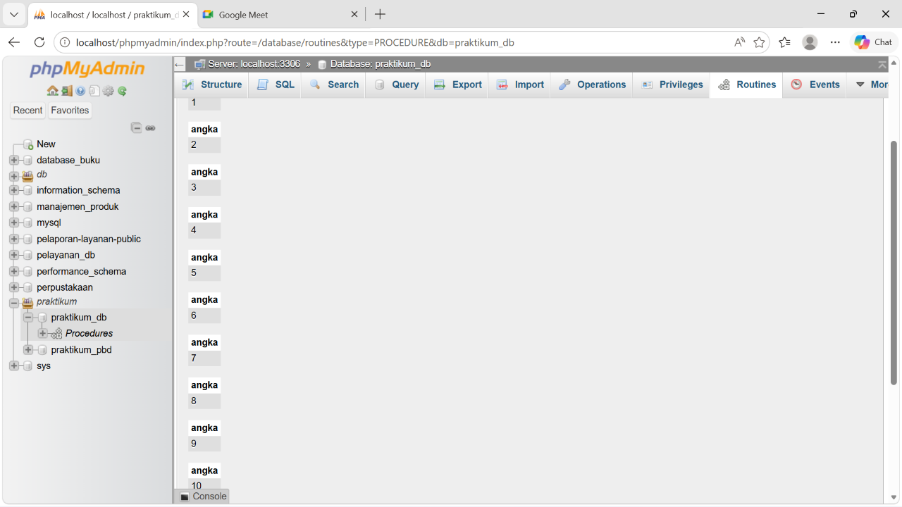

- SCRENSHOOT WHILE LOOP
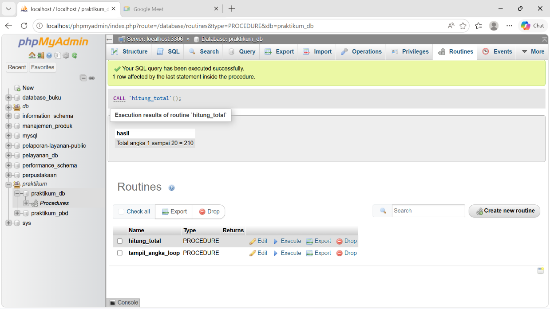
- SCRENSHOOT WHILE LOOP
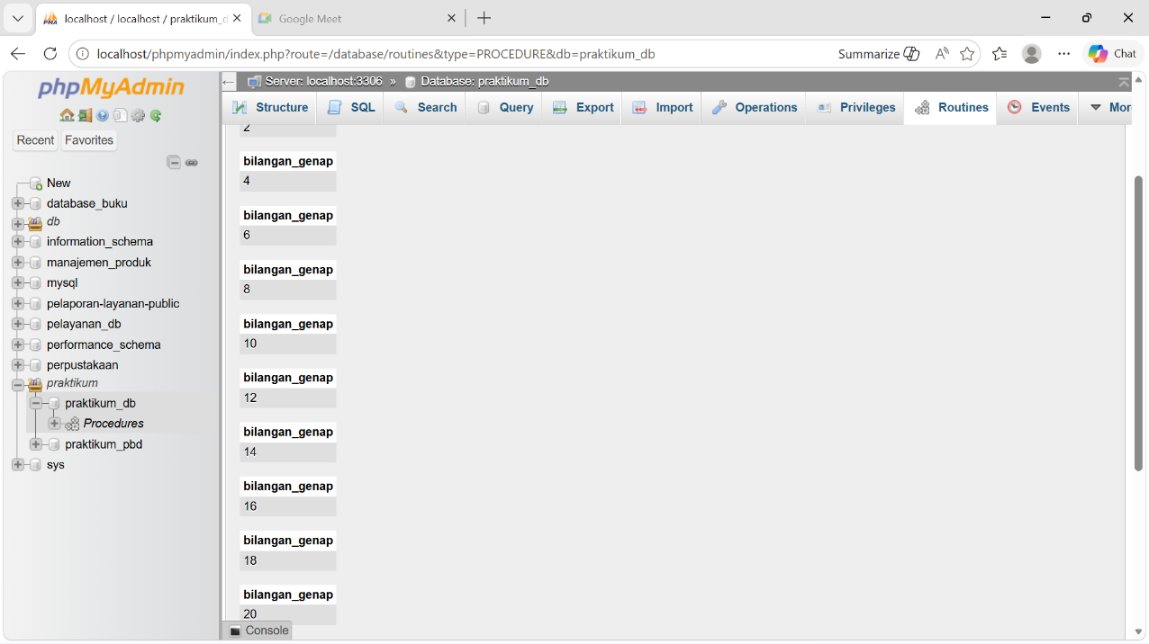

- SCRENSHOOT MENGHITUNG TOTAL BELANJA
